|  |  |
| --- | --- |
| **Name** | Muhammad Arslan Raza |
| **Roll no.** | 2020-EE-403 |
| **Section** | A |

**Lab 2**

**Experiment no. 1**

**Observe the working principle of Two Stroke Petrol/Spark Ignition Engine**

**1: Introduction:**

A two-stroke (or two-cycle) engine is a type of [internal combustion engine](https://en.wikipedia.org/wiki/Internal_combustion_engine) which completes a power cycle with two strokes (up and down movements) of the [piston](https://en.wikipedia.org/wiki/Piston) during only one crankshaft revolution.

* **Actually stroke means movement of piston between top position of piston and bottom position of piston**

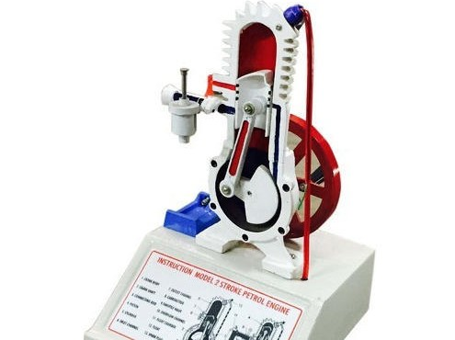 In a two-stroke engine, the end of the combustion stroke and the beginning of the compression stroke happen simultaneously, with the intake and exhaust (or [scavenging](https://en.wikipedia.org/wiki/Scavenging_(automotive))) functions occurring at the same time. A 2-stroke engine is an engine in which there are 2 phases in a cycle of operation of the engine. Stroke basically, means the sudden movement of piston which is converted into a rotary motion at crankshaft. This rotation is coupled to gear system and differential, which turns the wheel. Reciprocating motion used in reciprocating engines and other mechanisms is back and forth motion. Each cycle of reciprocation consists of two opposite motions, there is a motion in one direction and then a motion back in the opposite direction. Each of this motion is called **stroke**. There are basically 4 processes in a petrol/spark engine- **Intake** (of fuel), **Compression**, **Ignition** and **Exhaust**. Intake of fuel and Compression happens in the first stroke and the next 2 processes in the second stroke.

Figure 1: Model of Two Stroke Petrol Engine.

**Parts List and Details:**

1. 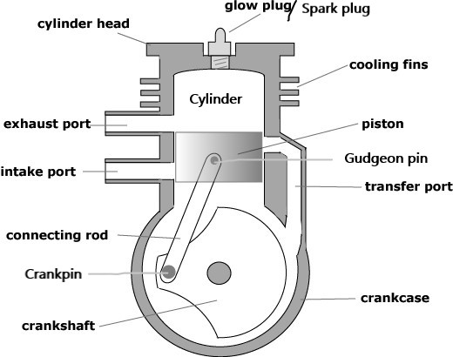Inlet port
2. Carburetor
3. Transfer port
4. Piston
5. Exit hole
6. Cylinder
7. Spark plug/glow plug
8. Connecting rod
9. Crankshaft
10. Crank case
11. Gudgeon pin
12. Integral fins/cooling fins

Figure2:Labelled Diagram of Two Stroke Petrol Engine.

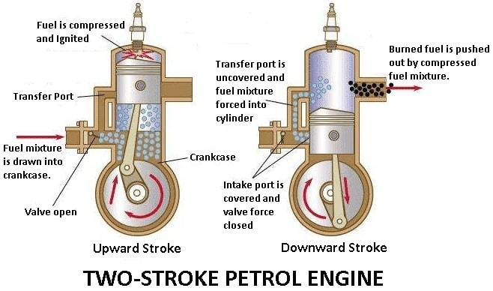**Inlet port:**

* The inlet ports connect to a transfer passage leading to the fully enclosed crankcase. Air trapped in the crankcase is compressed by the decent of the piston on its power stroke as shown

**Use:**

* Intake ports are needed for the air fuel mixture to be properly directed into the combustion chamber for proper combustion.

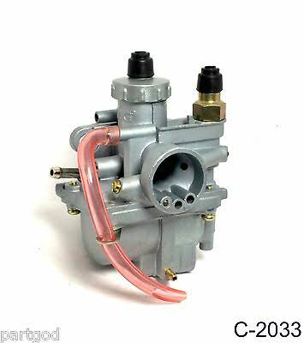**Carburetor:**

* A carburetor is a device that mixes air and fuel for internal combustions in the proper air fuel ratio for combustion.

**Use:**

* It is used to control the speed of vehicles. It converts petrol into fine droplets and mixes it with air in such a way that it burns smoothly in engine.

**Transfer port:**

* 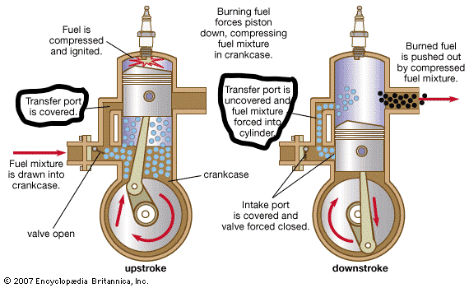It is the passage b/w the cylinder and crankcase. This passage transport fresh air/fuel mixture supplied by the intake from the crankcase to the area of the cylinder currently above the cylinder as shown in figure.

**Use:**

* It cools the cylinder. It is also uses in scavenging of the exhaust gases to the outlet.

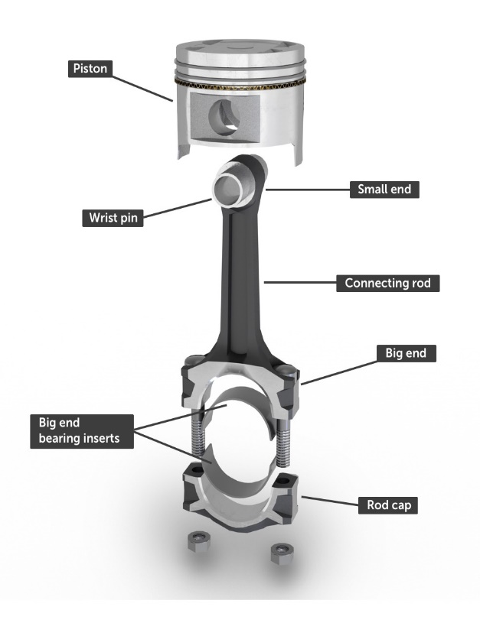**Piston:**

* Piston is another vital engine component. It is a partly hollow cylindrical part closed at one end, fitted to each of the engine's cylinders and attached to the crankshaft by a connecting rod. Each piston moves up and down in its cylinder, transmitting power created by the exploding fuel to the crankshaft via a connecting rod.

**Outlet Port:**

* The outlet port is higher and thus is exposed first during the power stroke to allow the exhaust gases to begin flowing out of the cylinder.
* The point in the cylinder through which the burnt gases are exhausted out.

**Cylinder:**

* 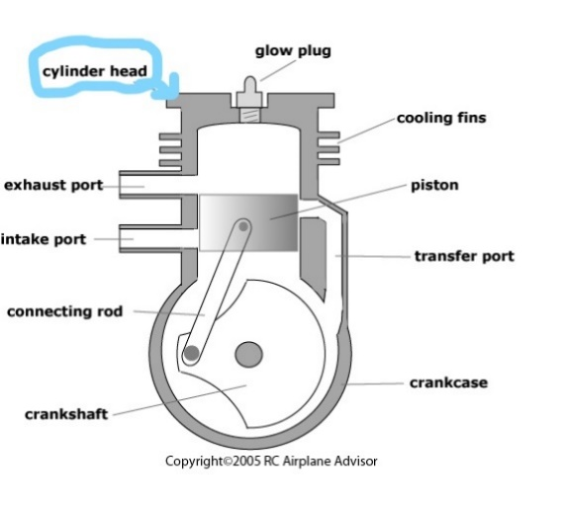In two stroke engines, on the other hand, the crankcase is serving as a pressurization chamber to force fuel air into the chamber
* So, it can’t hold thick oil. Instead you mix oil in with gas to lubricate the crankshaft, connecting rod and cylinder walls as shown in figure.

**Use:**

* It not also prevents the air/fuel from travelling into the exhaust port, but also creates a stirring turbulence that enhances combustion efficiency, power and economy

**Spark plug:**

* 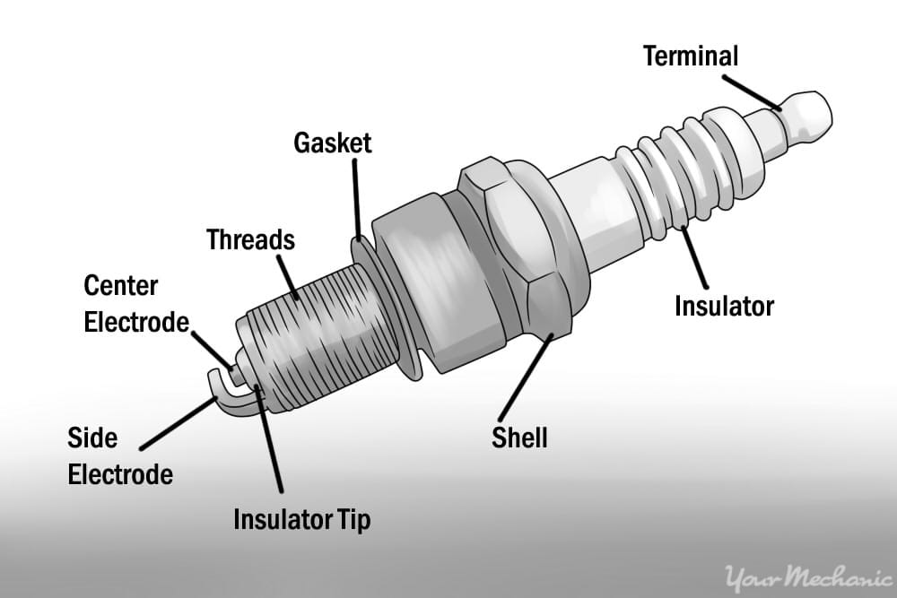It is a device for delivering electric current from an

Ignition chamber to of a spark ignition to ignite the mixture of air/fuel by an electric spark, while containing the combustion pressure within the engine

As shown in Figure

**Use:**

* The combustion and reduces the specific combustion automatically will help to increase the efficiency.

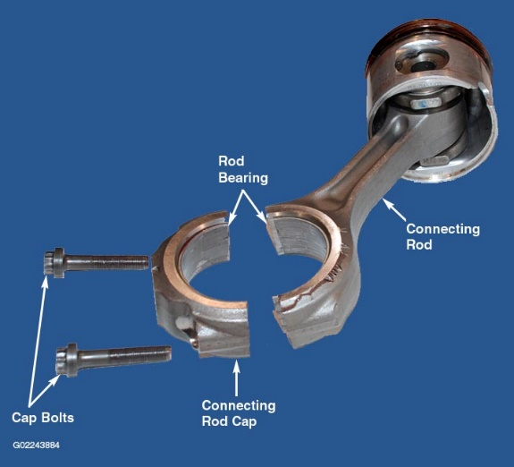**Connecting rod:**

* A connecting rod is also known as con rod is a part

Of the piston engine which connects the piston to crankshaft. Together with the crank the connecting rods converts the reciprocating motion of the piston into the rotation of the crankshaft as shown in Figure:

**Use:**

* It is required to transmit the compressive and tensile forces from the piston and rotate at both ends. It is mostly used in internal combustion engines and steam engines.

**Crankshaft:**

* 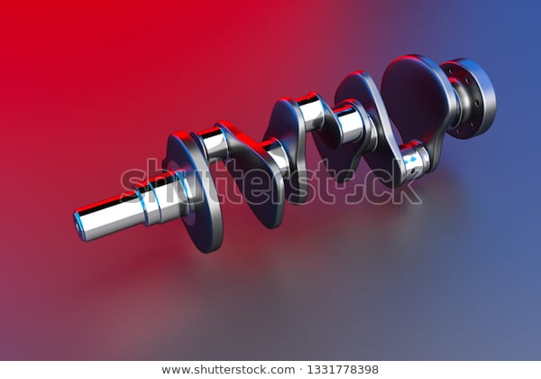A crankshaft is a rotating shaft

(In conjunction with the connecting rods) converts the reciprocating motion of the pistons

as shown in figure

**Use:**

* Crankshaft is commonly used in internal combustion engines and consists of series of crank and crank pins to which the connecting rods are attached.

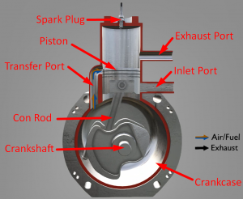**Crank Case:**

* In a two stroke engines crankcase is serving as a pressurization chamber to force air/fuel into the cylinder so it can hold a two-stroke engine typically use crankcase compression design, resulting in the fuel/air mixture passing through the crankcase before entering the cylinder as shown in figure.

**Gudgeon pin:**

The [gudgeon](https://en.wikipedia.org/wiki/Gudgeon) pin/wrist pin connects the [piston](https://en.wikipedia.org/wiki/Piston) to the connecting rod, and provides a bearing for the connecting rod to pivot upon as the piston moves.

**Integral fins:**

The lining outside the engine is integral fins that externally cools the cylinder.

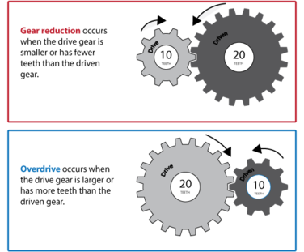**Driver and Driven Gear**

Gears are used to transfer kinetic energy in a rotary motion using levers. Each tooth on a gear can be simplified as a lever which can be used to produce a mechanical advantage in a system. In a geared system there is a 'Driver', the gear which is powered, and a 'Driven', the gear that is moved. When the two engage the rotary motion is reversed. The rate of rotation is given in RPM (revolutions per minute) and calculated

**input speed/gear ratio**

**There are 3 reasons for implementing gears into a system:**

**Change Speed:** This is achieved by making the number of teeth on each gear different. The larger 'Driver' gear has a greater number of teeth than the smaller 'Driven' gear, increasing the number of rotations it makes. The difference between each gear is given as a ratio.

Driven gear teeth/Driver gear teeth = Ratio

**Change Force:** If the 'Driver' gear is smaller than the 'Driven' gear the speed of rotation is decreased, however, the force applied is increased. The increase in torque occurs much in the same way a lever is given a mechanical advantage by using differing lengths. A gear is simply multiple levers arranged in a circle

**Change Direction of Force:** When two gears engage the direction of force is reversed as one pushes the other away. Motion can be changed in a linear direction as shown or at an angle by altering the shape of the tooth profiles

**Explanation**

**PROCESSES:**

**There are following processes in Two Stroke Engine:**

**Intake:**

* During the intake stroke, the fuel air mixture from the carburetor is taken in from the intake valve and the exhaust from the previous cycle is expelled from the exhaust shaft. Actually, exchange of fuel-air mixture with exhaust gases is not perfect. The piston creates an area of flow pressure when it is at the beginning of intake stroke and sucks in air from both intake and exhaust shaft. Hence, exhaust gases are sucked back into the engine for combustion and the fuel-air mixture from the intake shaft are expelled.

**Compression:**

* During the compression stroke, the fuel-air mixture (along with some exhaust gases) is compressed. This is the first half of cycle until the piston reaches its highest point in the cylinder .The next half of the cycle occurs when a spark plug ignites the fuel-air mixture when the piston is at its peak, thereby causing the violent expansion of gases and pushing the piston back down to power the crankshaft and ultimately your vehicle.(This is sometime known as (“Power Stroke”)

**Ignition:**

During upward stroke of a 2-stroke spark ignition cycle, the piston moves upward i.e. from the bottom dead center to the top dead center. While moving up, it compresses the air-fuel mixture in the combustion chamber. The spark plug ignites the compressed charge in the combustion chamber and produces the power stroke.

**Power**:

* At the top of the stroke, the spark plug ignites the fuel mixture. The burning fuel expands, driving the piston downward, to complete the cycle. (At the same time, another crankcase compression stroke is happening beneath the piston.)

**Exhaust:**

Toward the end of the stroke, the piston exposes the intake port, allowing the compressed fuel/air mixture in the crankcase to escape around the piston into the main cylinder. This expels the exhaust gasses out the exhaust port, usually located on theopposite side of the cylinder. Unfortunately, some of the fresh fuel mixture is usually expelled as well.

**WORKING OF THE CYCLE**

* In a two-stroke engine, the end of the combustion stroke and the beginning of the compression stroke happen simultaneously, with the intake and exhaust functions occurring at the same time. Fuel enters from the carburetor and reaches to cylinder for accumulation. There is a transfer port, from which fuel reaches to the top level of the engine and then there pressure exists, which causes to burn the fuel. Likely, transfer port and inlet port there is a exist port, from which fuel come out.
* 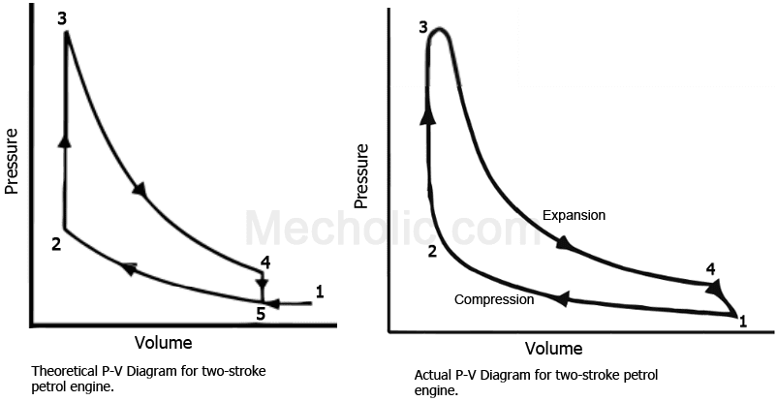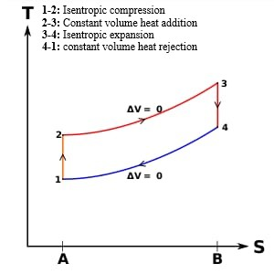The whole process is represented by **P-V diagram** and **T-S diagram:**

Figure 1:T-S diagram of Working of Two Stroke Petrol Engine.

Figure 2: P-V diagram of Working of Two Stroke Petrol Engine.

|  |  |
| --- | --- |
| **Advantages:** | **Disadvantages**: |
| The power developed will be nearly twice that of four stroke engine of same dimension and operating at the same speed. The work required to overcome the friction of the exhaust and suction strokes is saved. Low weight. Construction is simple. Low thermal efficiency. Can run at higher speeds (5000 rpm). Low maintenance cost  **1RPM=4 Process=2 Strokes** | As cycle is repeating itself again and again, a part of the fresh mixture is lost through exhaust port. Part of the piston stroke is lost. Heavy consumption of lubricating oil. Two-stroke engines are not fuel efficient, so we would get fewer miles per gallon. |

**Application:**

* Two stroke engine are preferred when mechanically simplicity, light weight, and high power to weight ratios are traditionally technique of mixing oil into fuel, they also have the advantage of working in any orientation as there is no oil reservoir dependent on gravity; this is an essential proper power tools such as chainsaws. Therefore, it has been used in large diesel engines, mostly large industrial and marine engines, as well as some trucks and heavy machinery.

**Two stroke Petrol Engine is used in following machines;**

* Dirt Bike
* Lawn mowers
* Outboard engines
* Chain saws
* Line Trimmers
* Jet Skis
* Snowmobiles
* Model Air Planes
* Light Motorcycles
* Go Karts, Ultra-lights, Scooters Go-Karts etc.